Direct/ Indirect Discourse

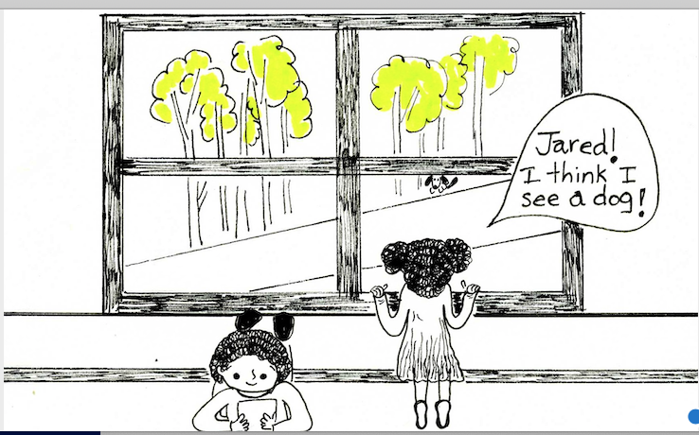

Jared was reading a book. Josie looked out of the window.
She saw a dog. Josie said, “Jared, I think I see a dog!”

What did Josie say?

How do you know what Josie said?

A different way to show discourse:

Jared was reading a book at his desk. Josie looked out the window.
She told Jared that she saw a dog under the tree.

