Adverbial Phrase: Where (prepositional phrase Where?)

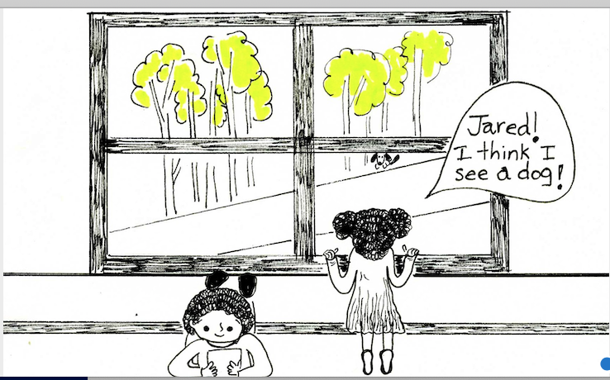

Jared is in the house.
Josie is in the house.
A dog is in the yard.
A dog is under a tree.

- Where is Jared?

- Where is Josie?

- Where is the dog?

___________________________________________________________________________

