Syntax N+ V

N+V be -ing + N
N + V be -ing + adv

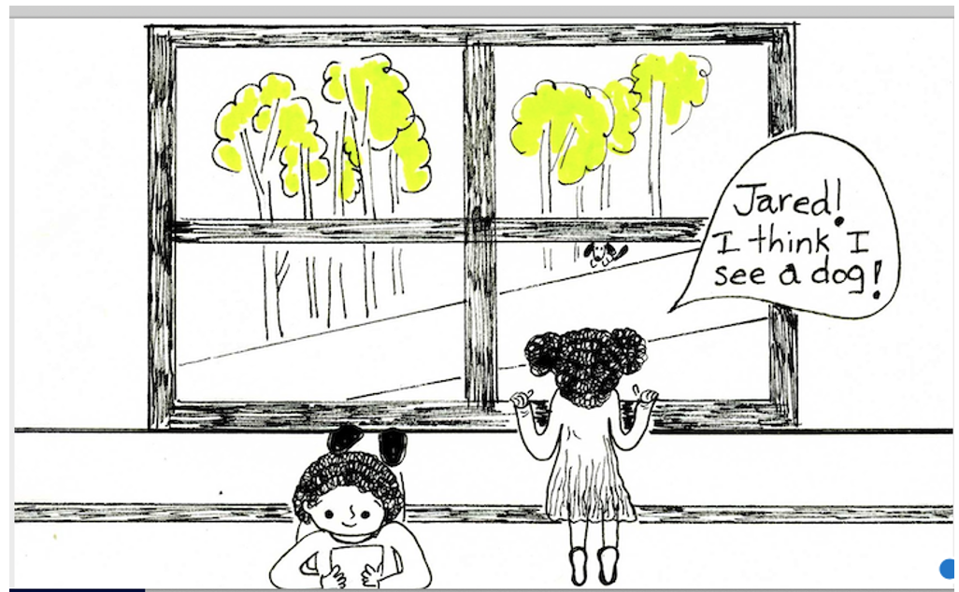

Jared is reading a book.
Josie is looking at a dog.
A dog is sitting under a tree.

What is Jared doing?

What is Josie doing?

What is the dog doing?

_____________________________________________________________________________

