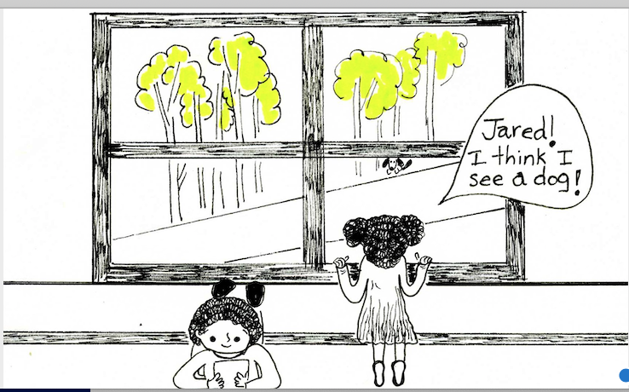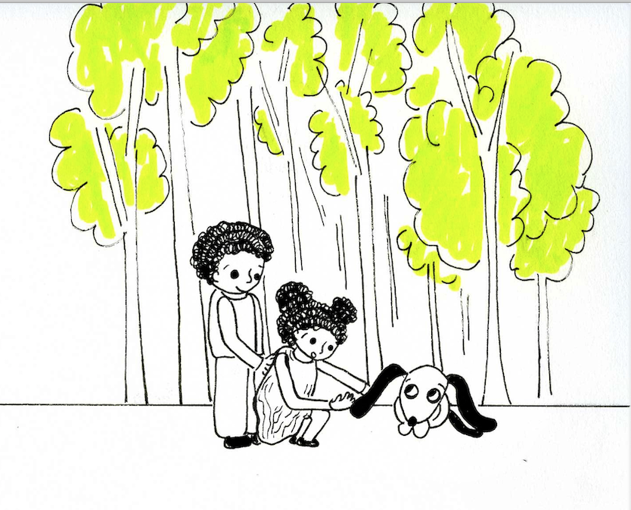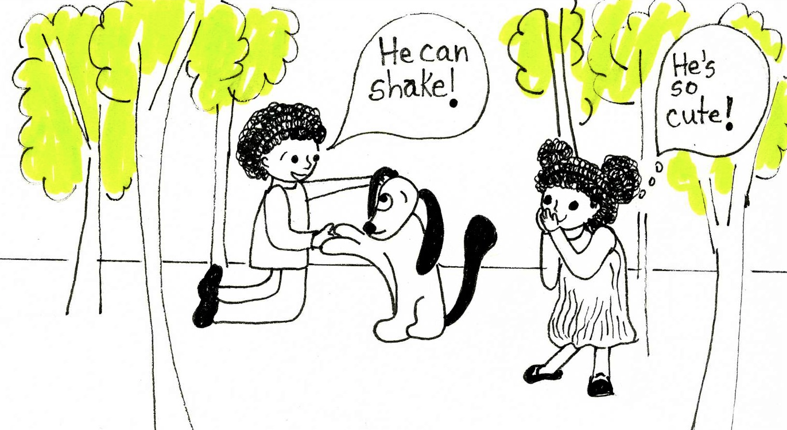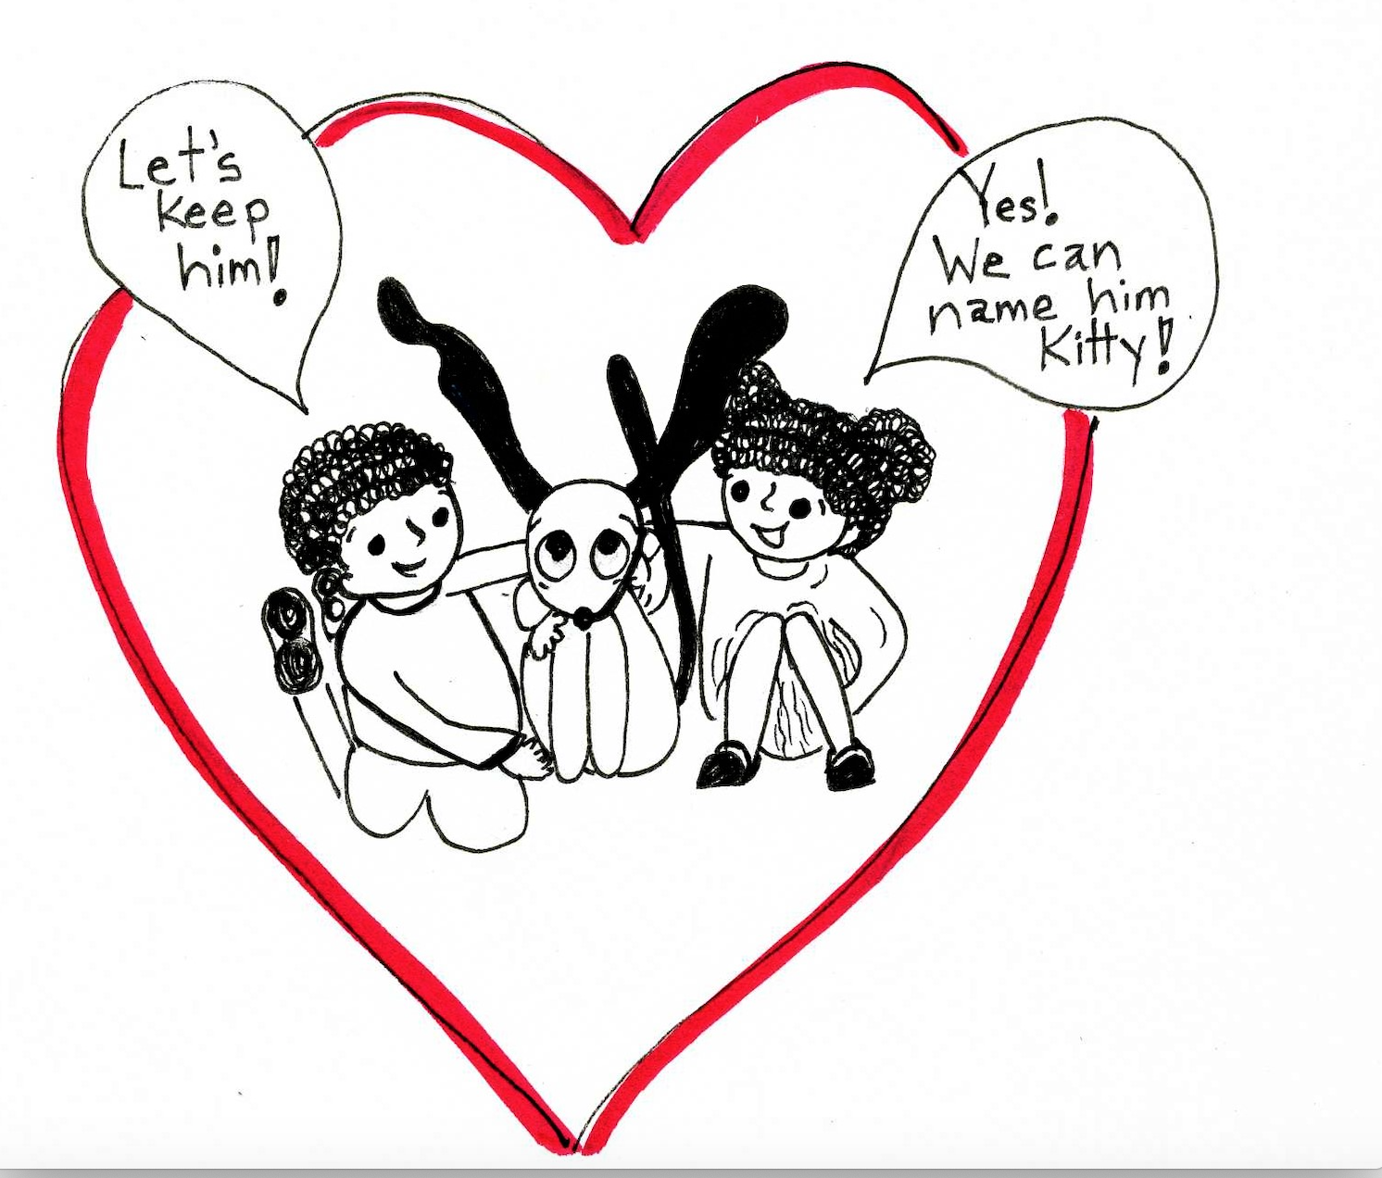

A B C D
Sequencing Events and Dialogue:
(Look at the pictures. Read the sentences. Write A, B, or C on the line that matches the sentence.)

____________ The dog looked surprised!

____________ Josie said, “He’s so cute!”

_____________Josie and Jared went outside. They petted the dog.

_____________Jared shook hands with the dog. Jared said, “He can shake!”

____________ Jared said, “Let’s keep him.”

___________ Josie said, “Yes, we can name him Kitty!”

_____________Josie was looking out of the window. Josie said, “Jared, I think I see a dog.”

Why was the dog surprised?

What did Jared say to Josie?

What did Josie say to Jared?

