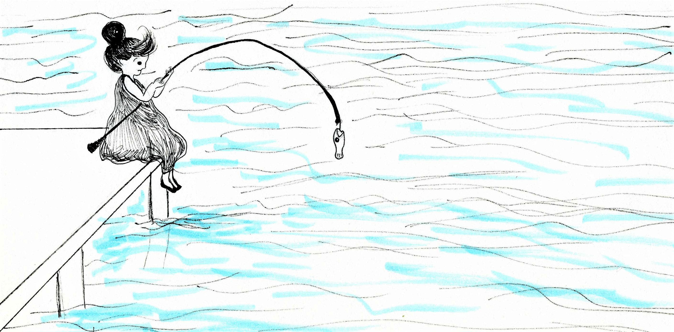

One day, Mara went fishing.
She caught a fish!
She pulled the fish out of the water.

What is Mara doing?____________________________________________________

What did Mara catch?___________________________________________________

What did Mara pull out of the water?_______________________________________

How do you think the fish feels?____________________________________________

How would you feel if you were a fish out of the water?

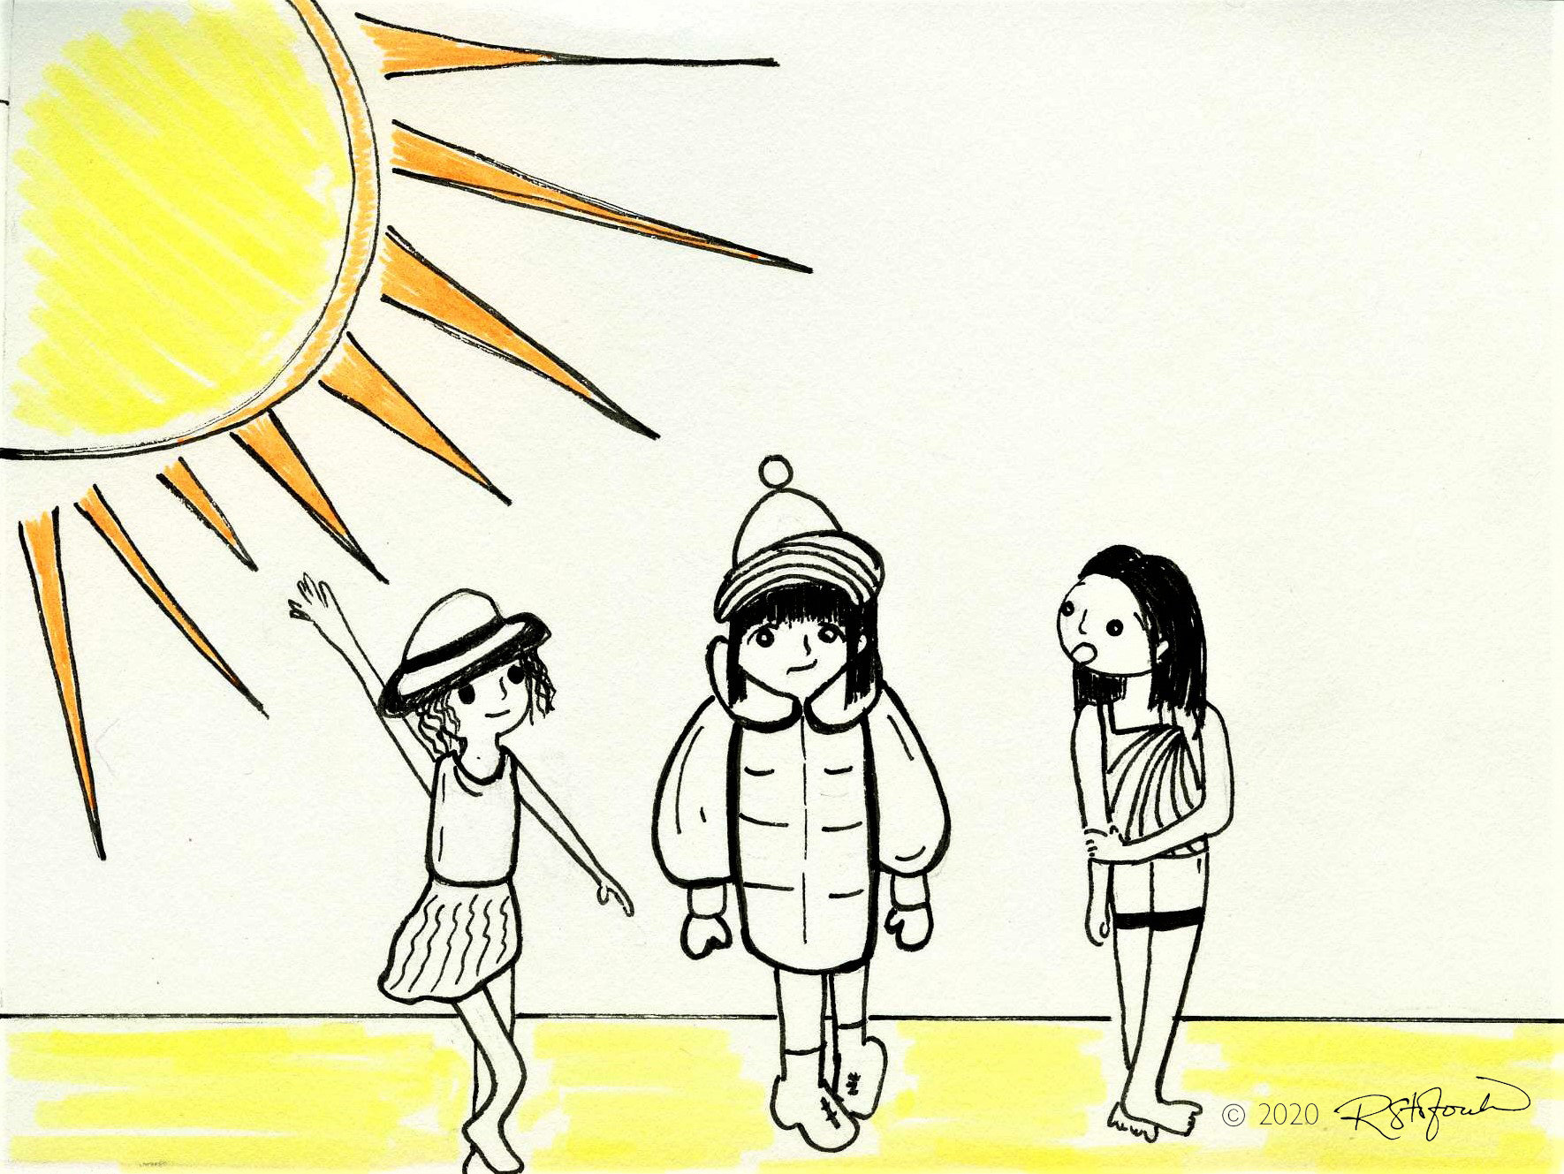

Mara met her friends on the beach.
Mara lives in Alaska. She visited her friends in California.
Mara felt like a fish out of water!

Where is Mara?___________________________________________

Where does Mara live?_____________________________________

Who is Mara visiting in California?____________________________

Why do you think Mara is wearing a coat and a hat?_______________________________

How do you think Mara feels?_________________________________________________

When do you feel like a fish out of water?______________________________________

