Direct Discourse

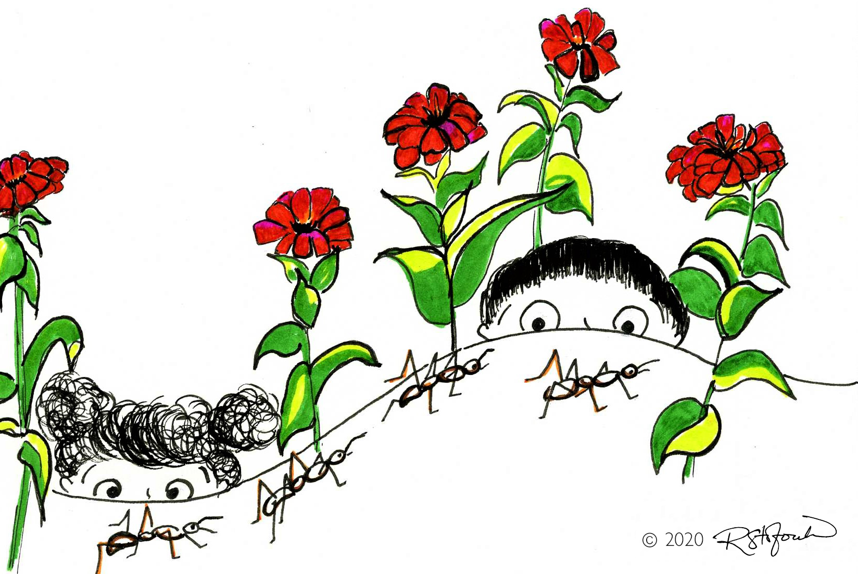

The ants were building an ant hill.
Maria and Marco watched the tiny ants.
The ants crawled up the ant hill.

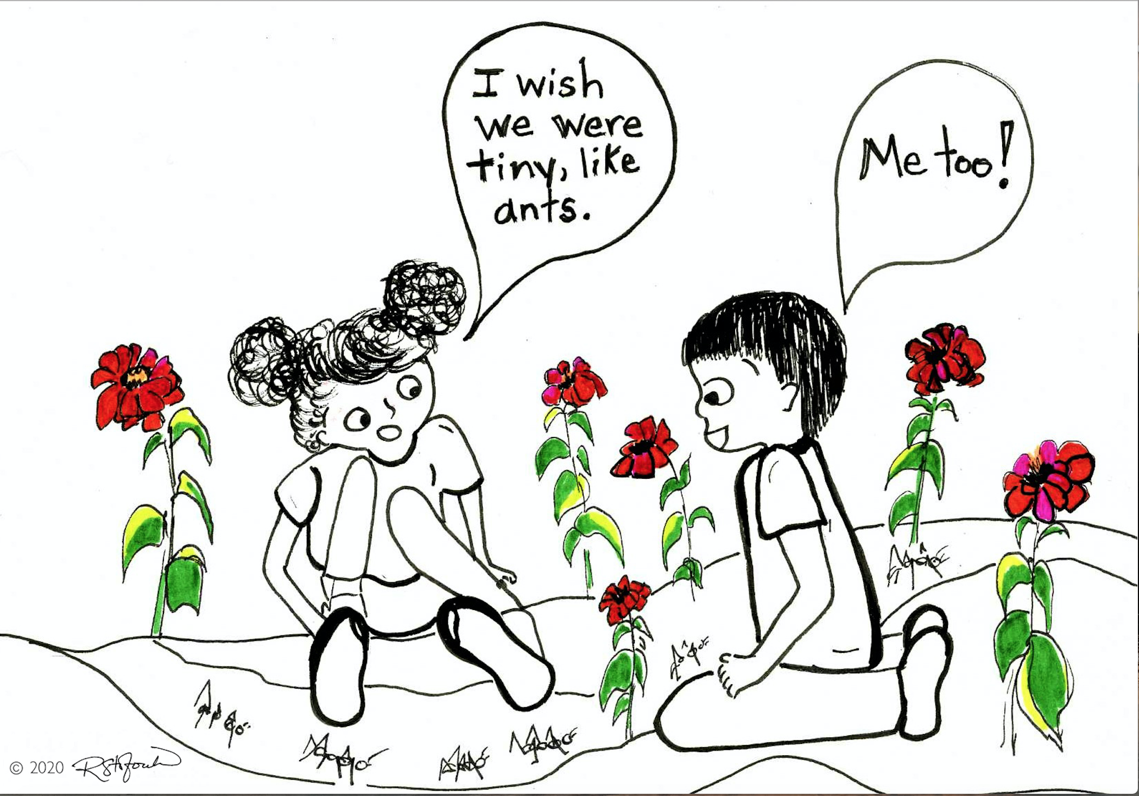

The tiny ants marched down the ant hill.
Maria and Marco liked to watch the tiny ants.

Maria said, “______________________________________________________________

________________________________________________________________________.”

Marco said, “____________________________________________________________.”

